Action Research: Teacher Perception of Impact Multimodal Strategies on Diverse Learner Academic Outcomes

Kathryn Spruiell
American College of Education
CI6103 – Curriculum and Instruction Design for Diversity
Dr. T. Hinchman
May 14, 2023
Action Research: Teacher Perception of Impact Multimodal Strategies on Diverse Learner Academic Outcomes
Action Research Purpose
Across the country, classrooms are filled with learners with diverse learning needs that traditional instructional strategies and methods may not address (ACE, 2023). Multimodal instructional strategies can help teachers support students' learning needs by providing more sensory entry points for students to connect instruction to learning. Multimodal strategies include linguistic, visual, tactile, artistic, and kinesthetic tasks and activities that interest learners (Moreno & Mayer, 2007). In addition, teachers increase their ability to differentiate for student needs using multimodal strategies to engage and motivate them, which is especially important for culturally diverse students with English language acquisition needs. Multimodal strategies that support diverse learners include Social Emotional Learning (SEL), problem-based learning (PBL), learning style modalities, concept mapping, and educational games.
This study described the research ontology, epistemology, methodology, and design of an action research study of teacher perceptions and understandings of implementing multimodal instructional strategies to meet the academic needs of diverse learners. The research study explored the ontology of teachers' multimodal instructional practices to differentiate instruction for students with diverse learning needs, including ELL, students with disabilities (SWD), and gifted and talented (GT) students. The epistemology of diverse learner needs, and effective implementation of multimodal instructional strategies offered opportunities to grow knowledge collaboratively with teacher leaders about their perceptions and understandings of multimodal strategies through inquiry and collaborative action research (Cordeiro et al., 2016). The nature of this research study built on pragmatism, action research, quantitative methods, and socio-cultural theory.
Problem Statement
This study answered the following problem. How do teacher leaders in an economically disadvantaged suburban elementary school in metro Atlanta, Georgia, perceive and understand multimodal instructional strategies and their impact on diverse learners such as ELL, SWD, and GT students?
Literature Review Findings
Multimodal strategies help teachers support differentiated instruction to target specific students' instructional accommodations and modifications. For instance, many English language learners (ELL) may accurately convey conversational language but need help accessing academic language, negatively impacting their ability to retain skills and concepts (Foulger & Jimenez-Silva, 2007). ELL students may need accommodations to change how they learn material or modify what teachers expect students to learn. The students' English Language and Literacy Plans (ELLPs) reflect necessary accommodations and modifications. SEL strategies support learning goals for ELL students through opportunities to build relationships, develop social awareness, and explore decision-making processes (Steed et al., 2021). PBL strategies provide flexible scenarios in which students engage with teachers and peers to build knowledge through hands-on problem-solving experiences that include trial and error and feedback (Lin, 2017). When teachers utilize learning style modalities such as visual, auditory, and kinesthetic (VAK) strategies, ELL students receive instruction in multiple sensory formats (Magfirah, 2018). Teachers use concept mapping to connect information through visual representations like charts, tables, flowcharts, t-charts, Venn diagrams, or timelines (Marzetta et al., 2018). The visuals help students process factual information and concepts without requiring extensive writing and work across visual and linguistic modalities. Educational games provide students with experiential learning that straddles visual, auditory, and tactile modalities within a real-world context. Games also provide positive, engaging activities that increase learning motivation (Vazirabad, 2013). Multimodal strategies can increase access to greater language acquisition possibilities for ELL students to help them meet their academic and ELLP goals and objectives (see Appendix A).
Social Emotional Learning (SEL) framework includes five competencies in which teachers use multimodal instructional strategies to improve students' academic and social experiences and outcomes (CASEL, 2023). The competencies include self-awareness, self-management, social awareness, relationships, and decision-making. Steed et al. (2021) conducted a study to explore and understand how early childhood teachers (Grades P-2) perceived their school and classroom SEL approach. The problem statement questioned; How do early childhood teachers in a western US state perceive the effectiveness of their school and classroom SEL programs regarding strengths and growth areas? This study explored a gap in the research regarding early childhood classrooms and social-emotional learning. SEL programs have the potential to positively impact student perceptions and social behaviors that drive positive student outcomes. Social skills learned through SEL support the problem-solving process, and SEL positively impacts problem-solving, friendships, and self-regulation for students in grades P-2.
Schools with SEL programs experienced increased attendance and achievement, which support early learning student needs.
The SEL study was a mixed-method study in which 1154 teachers completed a 41-question perception survey of closed and open-ended questions using the Qualtrics application (Steed et al., 2021). The study explored the qualitative question; Did early childhood teachers perceive their school and classroom SEL approaches as effective? The study also explored the quantitative question; what did early childhood teachers perceive as effective or ineffective features of their school and classroom SEL programs? The study results indicated that most teachers perceived their school and classroom SEL programs as effective. SEL program strengths included fewer discipline problems, more socially appropriate behaviors, increased student achievement, and positive student outcomes. The growth areas for the SEL programs included inconsistency and variance in program implementation, the need for ongoing training, and too many changes mid-program. The study's implications for ELL students included opportunities for relationship building and increased social awareness as scaffolds to improve academic outcomes.
Another multimodal strategy with substantial instructional implications for ELL students is problem-based learning (PBL). PBL is a teaching strategy incorporating real-world experiences as a learning context (Lin, 2017). Lin (2017) created a study in which teachers used PBL to increase student reading comprehension and motivation. The problem statement questioned; How will students in two Taiwanese college-level English classes respond to problem-based learning to improve English reading comprehension and attitudes towards English learning? English literacy education is essential for more significant opportunities for global careers, and PBL can support English language acquisition. In the study, PBL takes place in small groups with teachers scaffolding for students' real-time needs using a five-step problem-solving approach to English language acquisition. In addition, PBL offered opportunities for contextual learning experiences. When students engaged in multimodal strategies, like PBL, their motivation and attitudes towards the learning context improved, and positive student attitudes impacted successful learning outcomes.
The PBL study was quantitative and involved participants in two Taiwanese college English classes (Lin, 2017). One class was the control group in which teachers used traditional instructional strategies to teach English to students. The other class was the experimental treatment group in which teachers used PBL strategies to teach English to students. The treatment was the PBL instructional approach which consisted of a five-step problem-solving approach specifically designed for English acquisition. Both classes completed pre and post-tests for the academic context and a motivation assessment. The researcher compared and analyzed the scores for both groups. The students in the class that used the PBL treatment improved English reading comprehension and attitudes toward English language learning and motivation to learn English. This study underscored the importance of contextual learning and multimodal strategies for ELL students.
Learning style modalities are another multimodal approach in which contextual situations impact student outcomes (Magfirah, 2018). Learning style modalities include visual, auditory, and kinesthetic (VAK) learning preferences. Teachers utilize learning style instructional strategies to build on student strengths and growth areas in academic contexts. Magfirah (2018) explored whether there are significant differences in reading and listening comprehension for ELL students based on visual and auditory learning styles. The problem statement in this study questioned; How do visual and auditory learning styles impact reading and listening comprehension for eighth-grade students in Bahasa, Indonesia? Reading and listening are critical factors in English language development and have significant implications for EL learners. Learning Style preferences can support student achievement by building on strengths and supporting growth areas. Teachers must be aware of students' learning style preferences and their own so that instruction spans multiple access points for diverse learners.
The learning styles study utilized quantitative methods and design within a casual-comparative study. The participants consisted of 99 eighth-grade students across multiple classes in one school. Students completed a 15-question learning style questionnaire using a Likert scale to assess visual and auditory preferences. In addition, students completed a 30-question reading comprehension assessment and a 30-question listening comprehension assessment. The researcher compared the learning style preferences to the comprehension assessments. There was no statistical difference between visual and auditory learning styles in student achievement on the reading and listening comprehension assessments. The researcher suggested that multiple factors other than learning styles impact reading and listening comprehension, and more research was needed. The results of this study supported the assertion that ELL students require multiple modalities, contexts, and learning strategies for effective English language acquisition, including auditory and visual strategies.
Concept mapping is a visual and experiential strategy that supports instructional sustainability and equity for all learners, including diverse learner groups such as ELL and Gifted and talented (GT) students (Marzetta et al., 2018). The problem statement in this study questioned; How does curriculum mapping support equity and sustainability as an instructional strategy for fourth-grade students in an urban elementary school in Denver, Colorado?
In the science classroom context, sustainability means a balanced approach and equity instruction is a means to close achievement gaps among diverse learner groups. Science is a content area that requires equity due to global implications and environmental and scientific connections among all countries. Scientifically informed and educated students are college and career ready for science-based fields of study. Concept mapping is an instructional strategy that visually engages diverse learners through multiple modalities and contexts and supports students as they explore and explain scientific processes.
The concept mapping study utilized a mixed methods approach. The participants were 25 fourth-grade students (11 EL and 14 GT learners). Students completed pre and post-test concept maps as an assessment of science learning outcomes for a study of eco-systems. Researchers scored concept maps using a rubric and interviews. In addition, two researchers scored each pre and post-test to ensure inter-rater reliability. There was no statistical difference in the learning outcomes for EL and GT learners, indicating that concept mapping is an equitable instructional practice that increases academic outcomes for all learners.
An additional multimodal instructional strategy is educational games. Educational games are an instructional medium that motivates and engages all learners, including diverse learning groups such as ELL students (Vazirabad, 2013). Vazirabad (2013) used educational games as a novel way to study communication strategies that are more effective for supporting English language instruction for EL learners. The problem statement in this study questioned; What are the most effective communication strategies that EL learners and teachers can use through educational games in a study of college EL learners at a university in Essex, England?
Educational games provide high interest and motivational context for instruction. Additionally, educational games proved a unique context for observing communication strategies that support EL learners. The rationale for this study was that there needs to be more practical research on how communication strategies compare effectiveness. Communication strategies include paraphrasing, approximation, hesitation, reduction, borrowed words, and invented or anglicized words.
The educational games study incorporated qualitative methodology and design. The researchers explored a case study of six college EL learners and six English tutors. Students and tutors played the game "Spot the Differences" as an English language acquisition exercise. The researcher conducted observations of students and tutors interacting during the games using videos as observation tools. The researcher interviewed all 12 participants about their perceptions of the effectiveness of the communications strategies used during the games. The top communication strategies based on observational coding were body language, hesitation, and paraphrasing. Teacher perceptions differed from observational data. The teachers believed that providing direct modeling, using vocabulary, and pushing through hesitations were better strategies. The observation data proved otherwise. This study underscored that teacher and student beliefs impacted student achievement outcomes. The study also found educational games an effective strategy to build on communication strategies for ELL students.
Methodology
Action research, collaboration, and perceptual investigations work well with a theoretical framework such as Lev Vygotsky's socio-cultural theory (Das, 2020). The socio-cultural theory describes instructional social interactions in which teachers engage students in collaborative cycles of learning and modeling. Teachers act as a More Knowledgeable Other (MKO) and model direct instruction for students in a context that is neither too challenging nor too simple. This context is known as the Zone of Proximal Development (ZPD) (Huang, 2021). Collaborative and social instructional interactions provide a context for the MKO to appropriately model strategies within the ZPD to engage all learners in effective instruction that results in positive student outcomes. An action research study that explores teacher perceptions of multimodal instructional strategies corresponds to a socio-cultural theoretical framework.
This action research study utilized a descriptive quantitative research design to gather survey data about teacher perceptions to gain new knowledge. First, a convenience sample of five teacher leaders completed a perception survey about multimodal instructional strategies and their impact on the learning outcomes of diverse learner groups (see Appendix B). Then, using a web-based frequency calculator, the researcher analyzed descriptive statistical data from closed-ended Likert scale questions (AtoZMath, 2023). The researcher also summarized and reported findings from the open-ended survey questions. Finally, the researcher used the data to answer the following research questions.
Research Questions
- How do teacher leaders perceive specific multimodal instructional strategies and a means to differentiate instruction for diverse learner groups in their school?
- How do teacher leaders perceive the impact of specific multimodal instructional strategies on student outcomes?
Participants
The participants in the study included five teacher leaders who served as a convenience sample of teachers from the selected elementary school setting for the study (see Appendix D). All five teacher leaders served on the school's leadership team, including the school's K-5 instructional coach and grade chairpersons from the second, third, and fourth grades. All five teachers hold certifications in gifted (GT) education, and four hold certifications in English language learner (ELL) education. All the teachers work with culturally diverse students. In addition, four teachers have coaching endorsements, one teacher has a reading endorsement, and one teacher has a math endorsement on their teaching certificates. In terms of experience, three teachers have 6-10 years of experience, one teacher has less than six years, and one teacher has more than 20 years of experience. Regarding the highest educational level, one teacher has a master's degree, three teachers have specialist's degrees, and one has a doctoral degree. All five teachers had experience with the multimodal strategies described in the survey. The teacher participants represented educated, experienced teacher leaders who served diverse learners within the school.
Materials
The researcher used Microsoft Forms to create, collect, and analyze survey data. The survey included demographic questions about the teachers' instructional focus, experience, certification, and the diverse student groups they served. In addition, other questions included close-ended Likert scale multiple choice/multiple responses and open-ended questions. The teacher-leader participants received an email describing the anonymous survey and inviting them to complete the survey by clicking on the survey link included in the email (see Appendix C). The Microsoft Forms program generated bar graphs and pie charts illustrating the participants' demographic data (see Appendix D). The researcher used the web-based data collection tool, AtoZMath.com to analyze statistical data from the descriptive frequency data from the closed-ended survey questions (see Figure 1). In addition, the researcher used Microsoft Forms to generate a bar graph that illustrated subject area data for multimodal strategies (see Figure 2). Finally, the researcher used Microsoft Forms to capture participants' responses to open-ended questions regarding diverse learner groups and multimodal strategies (see Appendices E-G).
Data Collection
The researcher analyzed survey data using the Likert scale for closed-ended questions. Statistical data from the descriptive frequency data from the closed-ended survey questions included measures of central tendency (mean, median, and mode), variance, and standard deviation (see Figure 1). Participants reported the frequency (always, frequently, sometimes, rarely, or never) to which they used multimodal strategies in academic content areas (ELA, math, science, and social studies). The participants answered a closed-ended frequency question about the following multimodal strategies including social-emotional learning (SEL), problem-based learning (PBL), learning styles, educational games, and content mapping. In addition, participants reported academic content areas in which they used multimodal strategies the most. Finally, the researcher summarized and reported findings from the open-ended survey questions.
The results of the survey data collection describe the frequency in which teachers utilized multimodal strategies in academic content areas and their anecdotal perceptions of how multimodal strategies affect instruction and impact student outcomes. In addition, teachers shared their perceptions of their training on multimodal strategies. Regarding academic content areas, the teachers reported using multimodal strategies in all content areas except writing, emphasizing reading and math as primary content areas for multimodal strategies (see Figure 2). Regarding individual multimodal strategies, the strategy with the highest frequency mean was content mapping (3.8), and the lowest was PBL (3). The other three strategies scored in between, with SEL and learning styles scoring a frequency mean of 3.4 and educational games scoring a frequency mean of 3.6 (see Figure 1). All five multimodal strategies scored between the sometimes and frequently frequency range of implementation. In terms of median and mode, content mapping, educational games, and learning styles indicated more significant frequency implementation than SEL or PBL.
Teachers described their perceptions of the training they received on multimodal strategies in open-ended questions. The teachers' perceptions varied. All reported receiving training in multimodal strategies through local school or district professional development, certification or endorsement coursework, or graduate school courses. Two of the teachers reported more extensive training than the others in all areas. The multimodal strategies the teachers reported the most training on were content mapping, educational games, and SEL.
Additionally, teachers also described their perceptions of the effect of multimodal strategies on instruction and the impact of student outcomes of diverse learner groups through open-ended questions. Teachers summarized the instructional effect of multimodal strategies to increase engagement, accessibility, and scaffolding for diverse learners. The teachers also perceived multimodal strategies as a creative way to support diverse learners' understanding and retention of content skills. Furthermore, teachers summarized the student outcome impact of multimodal strategies as a more equitable path to more favorable mastery outcomes in overall comprehension and understanding of academic concepts. They perceived that the increased equity value offered students an increased chance of better outcomes.
Figure 1
Descriptive data from closed-ended survey questions
Closed-Ended Frequency Questions | Mean | Median | Mode | Variance | Standard Deviation
How often do you use multimodal instructional strategies in ELA, math, science, and social studies instruction? | μ=4.2 | 4 | {4, 5} | 0.56 | σ=1.0198039027186
How often do you incorporate Social Emotional Learning (SEL) strategies into content lessons in ELA, math, science, and social studies? | μ=3.4 | 3 | 3 | 0.88 | σ=1.0198039027186
How often do you incorporate Problem-Based Learning (PBL) strategies into content lessons in ELA, math, science, and social studies? | μ=3 | 3 | {2, 3} | 1.2 | σ=1.0954451150103
How often do you incorporate Learning Styles (VAK) strategies into content lessons in ELA, math, science, and social studies? | μ=3.4 | 4 | 4 | 1.04 | σ=1.0198039027186
How often do you incorporate Educational Game strategies into content lessons in ELA, math, science, and social studies? | μ=3.6 | 4 | 4 | .24 | σ=0.48989794855664
How often do you incorporate Concept Mapping strategies into content lessons in ELA, math, science, and social studies? | μ=3.8 | 4 | {3, 4} | 0.56 | σ=0.74833147735479
Note: Answers consisted of Always =5; Frequently =4, Sometimes =3, Rarely =2, and Never =1
Figure 2
Multimodal content areas
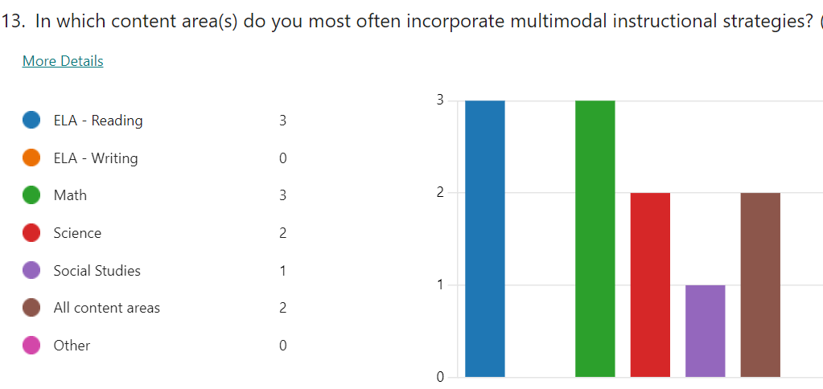

Conclusions

In conclusion, the data and results from the teacher perception survey provided valuable information about areas of strength and growth for instructional implementation of multimodal strategies and their impact on diverse learner groups. The implementation of multimodal strategies across the content areas of reading, math, social studies, and science was a strength area. Teachers unanimously perceived the strategies as a way to affect instruction and impact academic outcomes for diverse learners positively. Another area of strength included the amount of training teachers received for content mapping, educational games, and SEL. Overall, the results indicated a strong familiarity with and implementation of multimodal strategies among teacher leaders. However, some data indicated areas of needed improvement.
During the school year, all teachers participated in ongoing professional development incorporating problem-based learning in small-group math problem-solving instruction through modeling and feedback cycles. However, only two teacher leaders recognized and commented on the professional development. In addition, frequency data also indicated that teachers needed to connect the professional development and the modeled instruction to PBL, as PBL was perceived as the least frequently used strategy. This data indicated that further investigation and feedback are necessary to determine the effectiveness of PBL professional learning and that PBL is a strategy that requires more attention.
Another growth area is incorporating multimodal strategies into the writing content area. None of the teacher participants reported using multimodal strategies in writing, although two teachers indicated they used the strategies in all subject areas. Writing is an academic area that teachers can use to integrate instruction across multiple content areas. The perception data indicated that more professional learning and modeled instruction are needed to increase engaging integrated writing and multimodal strategies.
Finally, there are teacher leadership implications from the study data. The teacher participants represent one-third of the school’s leadership team. The leadership team meets at the end of the school year to plan programming, overall school goals, and new teacher mentoring for the next school year. Information from the teacher surveys in this action research study can inform leadership team decisions regarding local school improvement goals involving professional learning, modeled instruction, instructional coaching, and materials allocation for the next school year.

References
American College of Education. (2023). CI6103 Curriculum and instructional design for diversity: Evidence-based and multimodal instructional strategies. Module 4 [Part 1 presentation]. Canvas. https://ace.instructure.com/courses/1952604/modules/items/35233443
AtoZMath (2023). Mean, Median, and Mode Grouped Data Calculator. https://atozmath.com/StatsG.aspx?q=1
Cordeiro, L., Soares, C. B., & Rittenmeyer, L. (2016). Unscrambling method and methodology in action research traditions: Theoretical conceptualization of praxis and emancipation. Qualitative Research, 17(4), 395-407. https://doi.org/10.1177/1468794116674771
Das, K. (2020). Realistic mathematics & Vygotsky’s theories in mathematics education. Shanlax International Journal of Education, 9(1), 104-108. https://doi.org/10.34293/education.v9i1.3346
Foulger, T. S., & Jimenez-Silva, M. (2007). Enhancing the writing development of English language learners: Teacher perceptions of common technology in project-based learning. Journal of Research in Childhood Education, 22(2), 109-124. https://doi.org/10.1080/02568540709594616
Lin, L. (2017). Impacts of the problem-based learning pedagogy on English learners’ reading comprehension, strategy use, and active learning attitudes. Journal of Education and Training Studies, 5(6), 109. https://doi.org/10.11114/jets.v5i6.2320
Magfirah, T. (2018). Students’ reading and listening comprehension based on their learning styles. International Journal of Education, 10(2). https://doi.org/10.17509/ije.v10i2.8028
Marzetta, K., Mason, H., & Wee, B. (2018). ‘Sometimes they are fun and sometimes they are not’: Concept mapping with English language acquisition (ELA) and gifted/Talented (GT) elementary students learning science and sustainability. Education Sciences, 8(1), 13. https://doi.org/10.3390/educsci8010013
Moreno, R., & Mayer, R. (2007). Interactive multimodal learning environments. Educational Psychology Review, 19(3), 309-326. https://doi.org/10.1007/s10648-007-9047-2
Steed, E. A., Shapland, D., & Leech, N. (2021). Early childhood teachers’ perceptions of the effectiveness of their elementary school’s approach to social emotional learning: A mixed methods study. Early Childhood Education Journal, 50(7), 1121-1132. https://doi.org/10.1007/s10643-021-01248-4
The Collaborative for Academic, Social, and Emotional Learning (2023). CASEL. https://casel.org/
Vazirabad, A. F. (2013). The use of games to foster fluency among ESL learners. International Education Studies, 6(4). https://doi.org/10.5539/ies.v6n4p205

Appendix A
Multimodal Instructional Strategies – Action Research Studies
Social-Emotional Learning (SEL) (Steed et al., 2021)
Purpose  - SEL incorporates necessary and helpful multimodal skills that support positive student outcomes and achievement for all students including EL Learners  - Study sought to explore and understand how early childhood (P-2) teachers viewed their school and classroom SEL approach | Problem Statement  - How do early childhood (Grades P-2) teachers in a western US state perceive the effectiveness of their school and classroom SEL programs in terms of strengths and growth areas? |  |  |  |  | Methodology  - Mixed Methods  - Qualitative Question: Did early childhood (Grades P-2) teachers perceive that their school and classroom SEL approaches were effective?  - Quantitative Question: What did early childhood (Grades P-2) teachers perceive as effective or ineffective features of their school and classroom SEL program?  - 1154 (P-2) teachers completed a 41-question survey of closed and open-ended questions using Qualtrics to analyze results.
Literature Review Highlights  - SEL programs have the potential to positively impact student perceptions and social behaviors that drive positive student outcomes.  - Increased attendance and achievement  - Teachers need background training to effectively implement SEL programs.  - SEL competencies include Self-awareness, Self-monitoring, Social-Awareness, Relationship building, and Decision making.  - Social skills support the problem-solving process.  - SEL positively impacts problem-solving, Friendships, and self-regulation. |  |  |  |  | Conclusions  - The majority of teachers perceived their school and classroom SEL programs as effective.  - SEL program strengths included less discipline issues, more socially appropriate behaviors, increased student achievement, increased positive student outcomes.  - SEL program growth areas included issues with inconsistency and variance in program implementation, need for ongoing training, too many changes mid-program
Problem-Based Learning (PBL) (Lin, 2017)
Purpose  - Using PBL in English classes increase EL learners’ reading comprehension strategies and attitudes towards learning English.  - English is fundamental to learn as a medium for world-wide knowledge and skills. | Problem Statement  - How will students in two Taiwanese university English classes respond to problem-based learning as a strategy to improve English reading comprehension and attitudes towards English learning? |  |  |  |  | Methodology  - Quantitative Study  - Two classes of Taiwanese college students in English classes.  - One class was the control group and used traditional instructional approaches.  - One class was the experimental group and used the PBL approach.  - PBL was the treatment.  - Both classes completed pre-and posttests for reading comprehension and a questionnaire to assess motivation.
Literature Review Highlights  - English literacy education is essential for greater opportunities for world-wide careers.  - PBL is rooted in social learning theory.  - PBL takes place in small groups with teachers scaffolding for students’ real-time needs using a five-step problem solving approach to English Language acquisition.  - PBL uses contextual learning experiences.  - Student attitudes impact successful learning outcomes. |  |  |  | Conclusions  - The Students in the class that used the PBL treatment significantly improved English reading comprehension and attitudes towards English language learning and motivation to learn English.
Learning Styles – Visual, Auditory, Kinesthetic/Tactile (VAK) (Magfirah, 2018)
Purpose  - This study explores whether there are significant differences for reading and listening comprehension for EL learners based on visual and auditory learning styles.  - Reading and listening are key factors to English language development and have significant implications for EL learners. | Problem Statement  - How do visual and auditory learning styles impact reading and listening comprehension for Eighth grade students in Bahasa, Indonesia? |  |  |  |  | Methodology  - Quantitative Study  - Casual-comparative study  - 99 eighth grade students participated.  - Students completed a 15- question learning style questionnaire using a Likert scale to assess visual and auditory preferences.  - Students completed a 30-question reading comprehension assessment and a 30-question listening comprehension assessment.
Literature Review Highlights  - Learning Style preferences can support student achievement by building on strengths.  - Support for growth areas  - Teacher awareness of learning styles in important  - Reading and listening support ELL language acquisition. |  | Conclusions  - There was no statistical difference between visual and auditory learning styles in student achievement on reading and listening comprehension assessments.  - More research is needed.  - There are multiple factors that impact reading and listening comprehension than learning styles.
Educational Games (Vazirabad, 2013)
Purpose  - Educational games are an instructional medium that engages EL learners.  - Researchers used educational games as a medium the study communication strategies that are more effective for supporting English language instruction for EL learners. | Problem Statement  - What are the most effective communication strategies that EL learners and teachers can use through educational games in a study of college EL learners at a University in Essex, England? |  |  |  |  | Methodology  - Qualitative Study  - Case Study of six college EL learners and six English tutors  - Students played the game, “Spot the Differences,” as an English acquisition exercise.  - Researchers Completed observations of students and tutors interacting using videos.  - Researchers interviewed all 12 participants about perceptions of communications strategies.
Literature Review Highlights  - Educational games provide high interest and motivational context for instruction.  - Educational games proved a unique context for observing communication strategies that support EL learners.  - Communication strategies include paraphrase, approximation, hesitation, reduction, borrowed words and invented, or anglicized.  - There is a lack of practical research about how communication strategies compare to one another in terms of effectiveness. |  |  | Conclusions  - The top communication strategies based on observational coding were body language, hesitation, and paraphrasing.  - Teacher perceptions differed from observational data.  - Teacher and student beliefs impacted student achievement outcomes.
Concept Mapping (Marzetta et al., 2018)
Purpose  - Educational sustainability as a curriculum model  - Equity Pedagogy for science instruction  - Concept mapping is a strategy that supports sustainability and equity for all learners including EL learners and gifted and talented learners. | Problem Statement  - How does curriculum mapping support equity and sustainability as an instructional strategy for fourth grade students in an urban elementary school in Denver, Colorado? |  |  |  |  | Methodology  - Mixed Methods  - The participants were 25 fourth grade students including 11 EL learners and 14 GT learners.  - Students completed pre and posttest concept maps as a science assessment of learning outcomes for a study of eco-systems.  - Researchers scored concept maps using a rubric and interviews.  - Two researchers scored each pre and posttest.
Literature Review Highlights  - Sustainability means a balanced approach.  - Equity instruction is a means to close achievement gaps among diverse learner groups.  - Science is a content area that requires equity due to global implications and needs.  - Scientifically informed and educated students are college and career ready for science-based fields of study.  - Concept mapping engages divers learners through multiple modalities. |  |  |  | Conclusions  - There was no statistical difference in the learning outcomes for EL learners and GT learners indicating the concept mapping is an equitable instructional practice that increases academic outcomes for all learners.

Appendix B
Teacher Perception Survey - Multimodal Strategies

Multimodal Strategies are instructional strategies that help teachers support differentiated instructional tasks through multiple sensory experiences within a lesson. These tasks engage students through texts, images, visuals, audio, concrete objects, movement, or other sensory modalities combined. Please fill out the following survey to communicate your perception and understanding of multimodal instructional strategies and how these strategies impact diverse learning groups in daily general instruction.

1. What grade level(s) do you teach/support?
KK
1st
2nd
3rd
4th
5th
K-5

2. What diverse learner groups do you teach/support?
English Language Learners (ELL)
Students with Disabilities (SWD)
Gifted (FOCUS)
Economically Disadvantages (Title I)
Culturally Diverse Learners

3. How many years have you worked in education/teaching?
0-5 years
6-10 years
11-15 years
16-20 years
More than 20 years

4. What teaching endorsements or additional certifications do you hold?
ELL Endorsement
SPED Certification
Gifted Education Endorsement
Coaching Endorsement
Teacher Support Specialist
Reading Endorsement
Math Endorsement
Science or STEM Endorsement

5. What is your highest level of educational completion?
Bachelor’s Degree
Master’s degree
Specialist Degree
Doctoral Degree

6. Which multimodal instructional strategies are you familiar with using in your content instruction?
Social Emotional Learning (SEL)
Project Based Learning (PBL)
Learning Styles - Visual, Auditory, Kinesthetic (VAK)
Educational Games
Concept Mapping (Graphic Organizers, Flowcharts, T-Charts)

7. How often do you use multimodal instructional strategies in ELA, math, science, and social studies instruction?
Always
Frequently
Sometimes
Rarely
Never

8. How often do you incorporate Social Emotional Learning (SEL) strategies into content lessons in ELA, math, science, and social studies?
Always
Frequently
Sometimes
Rarely
Never

9. How often do you incorporate Project-Based Learning (PBL) strategies into content lessons in ELA, math, science, and social studies?
Always
Frequently
Sometimes
Rarely
Never

10. How often do you incorporate Learning Styles (VAK) strategies into content lessons in ELA, math, science, and social studies?
Always
Frequently
Sometimes
Rarely
Never

11. How often do you incorporate Educational Game strategies into content lessons in ELA, math, science, and social studies?
Always
Frequently
Sometimes
Rarely
Never

12. How often do you incorporate Concept Mapping strategies into content lessons in ELA, math, science, and social studies?
Always
Frequently
Sometimes
Rarely
Never

13. In which content area(s) do you most often incorporate multimodal instructional strategies?
ELA - Reading
ELA - Writing
Math
Science
Social Studies
All content areas
Other

14. Describe your experience and training in the following multimodal strategies: SEL, PBL, Learning Styles, Educational Games, and Concept Mapping.

15. How do multimodal strategies impact content instruction for diverse learner groups (ELL, Sped, Gifted, Culturally diverse Learners)?

16. How do multimodal strategies impact students' academic outcomes for diverse learner groups (ELL, Sped, Gifted, Culturally diverse Learners)?

Appendix C
Participant Invitation Email
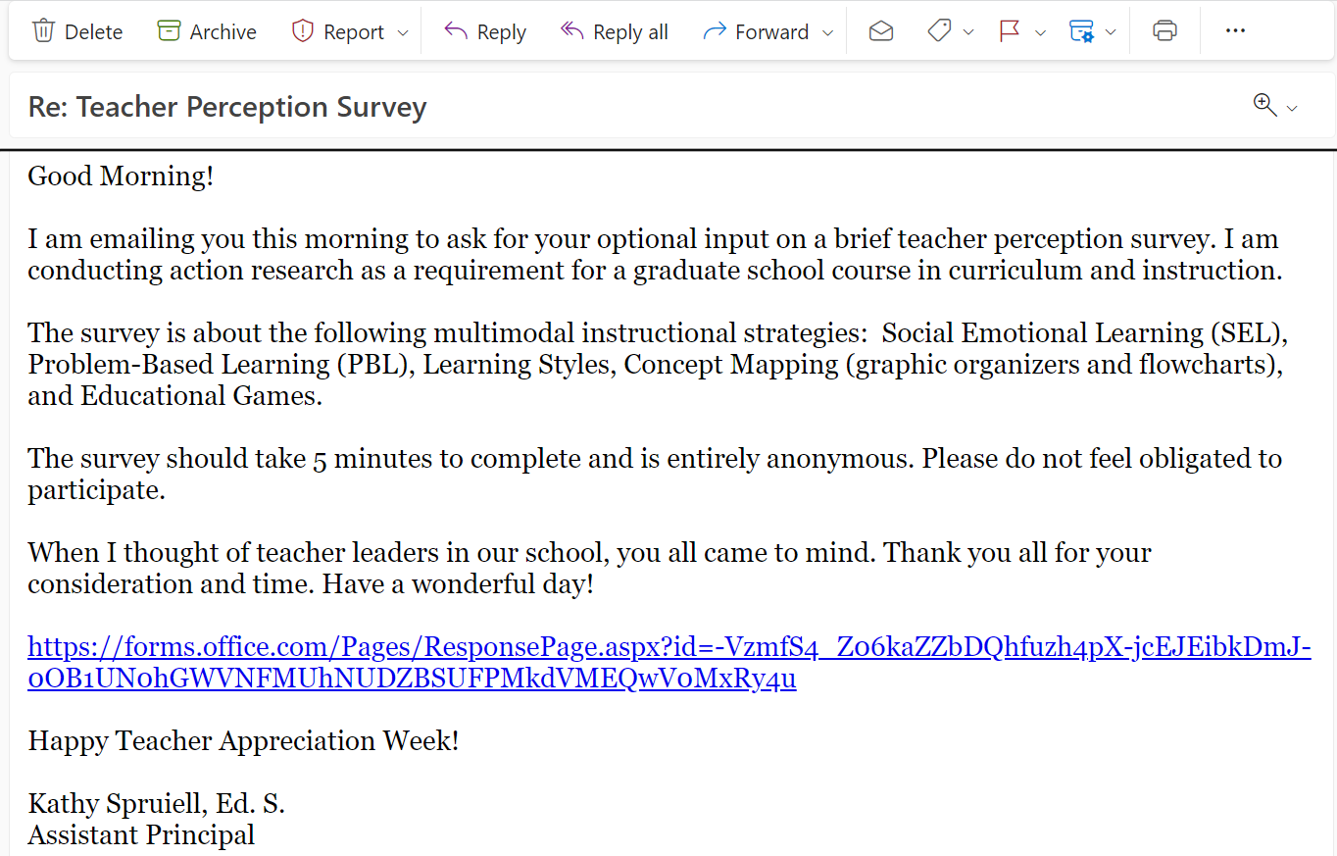

Appendix D
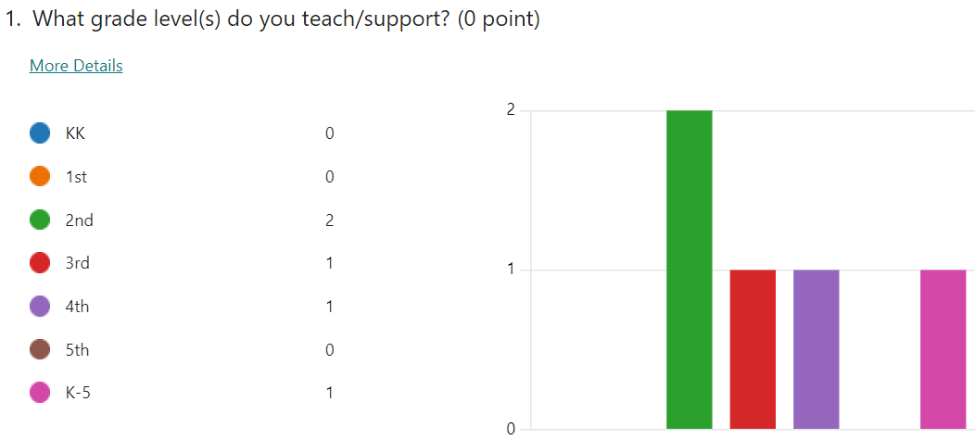
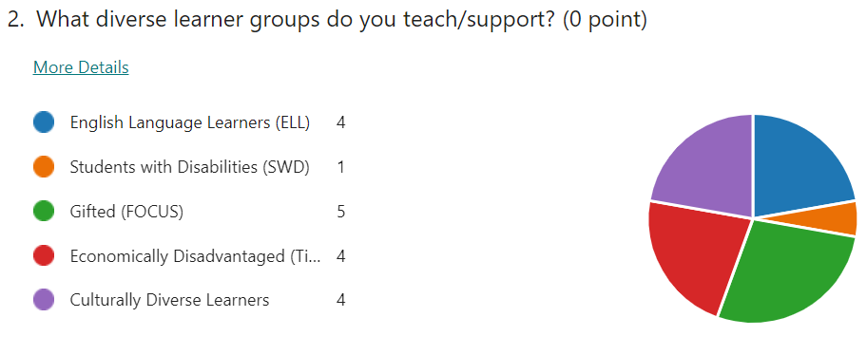
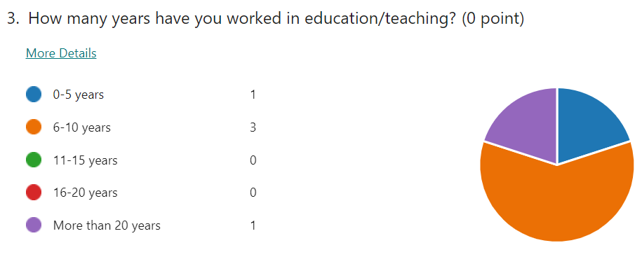
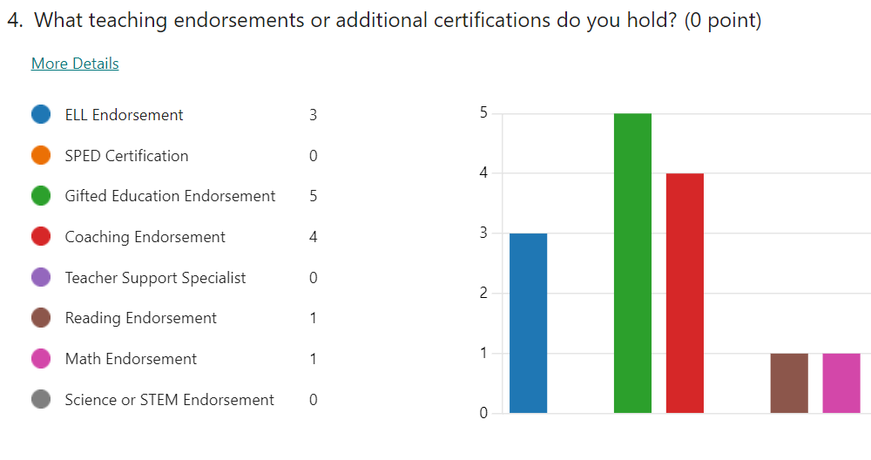
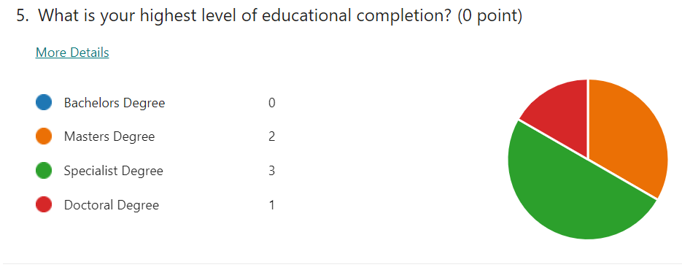
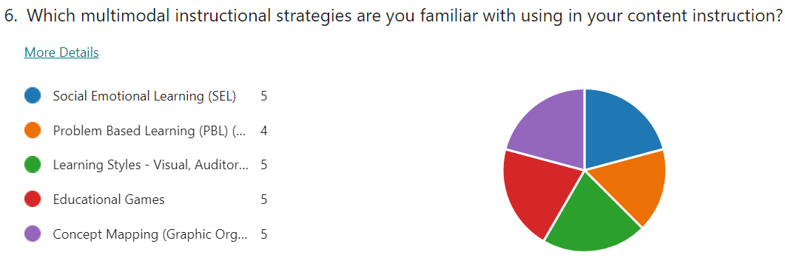
Appendix E
Describe your experience and training in the following multimodal strategies: SEL, PBL, Learning Styles, Educational Games, and Concept Mapping.
My experience and training have primarily taken place at my local school. My district and local school provide opportunities for professional development in each of those areas and the knowledge learned is implemented with my students. Additionally, if there is a particular skill or strategy not being offered as professional development I will research on my own.
During my experience using multimodal strategies, I have seen that students are more engaged with the tasks, the student conversations are richer, and the student outcomes for mastery are greater.
I've attended one SEL training this school year. I don't recall having any PBL trainings. I've had some experience and training with learning styles, educational games, and concept mapping.
Our district has provided SEL training. We also have been trained during CLT meetings at NES. My undergraduate degree trained me in educational games and the importance of thematic units. For concept mapping skills, I highly studied the different techniques during my gifted endorsement as well as during my specialist degree. We used concept mapping for our own studies. For the various modalities of learning, I became familiar with this in my undergraduate degree as well as in the courses for the gifted. For PBL, my master's degree helped with this as we studied the National Board of Certification Standards. We spent time delving into the need for critical thinking skills and the collaborative effort involving students, parents, staff, & all stakeholders. For my main work, I had to triangulate data which involved qualitative (SEL, Ed. Games, etc.) and quantitative data.
I have had many training experiences on SEL, PBL, Learning styles, and educational games at the local school level. After receiving training on SEL, it has been a part of our set daily routine as well as integrated throughout the content areas. Problem-based learning has been a focus during collaborative learning opportunities this year in which we delivered lessons, provided opportunities for peer and self-assessment, engaged in student-work analysis, and provided opportunities for revision based on new learning. Educational games have been a means of student engagement and learning for me, mostly in math. Through educational games, AKS and fluency-based concepts are able to be reinforced. Learning styles have been a topic of conversation consistently over the past few years. We've learned many different ways that students' learning styles can be attended to in the classroom. By considering the different learning styles in your classroom, you are providing students with more accessible learning opportunities based on how they learn best.

Appendix F
How do multimodal strategies impact content instruction for diverse learner groups (ELL, Sped, Gifted, Culturally diverse Learners)?
It allows students to be creative, encourages them to be independent thinkers - which allows them to take ownership of their learning. Additionally, it allows them to use different parts of their brain and they are able to retain information better.
The multimodal strategies impact content by engaging the teacher to dive deeper into the content and better understanding individual student needs when planning.
Multimodal strategies impact content instruction by helping students understand the content better.
The strategies that we use for these learners are many. There definitely needs to be a larger variety due to different needs. In order to scaffold learning, a teacher must use other methods besides the "normal"/ traditional ones (i.e., lecturing). Especially within the ELL curriculum this year, a focus was on using differentiated instructional needs. Thus, my classroom does not look like the typical one. Our methods of discovery meet the needs of all children. Children are normally up and moving around with a lot of small group and independent instruction.
Multimodal strategies impact content instruction for diverse learner groups by making content instruction more engaging, exciting, and accessible to all learners. Using multimodal strategies improves a students' learning experience by intentionally planning for content instruction based on the best modes of learning for the students in your classroom.

Appendix G
How do multimodal strategies impact students' academic outcomes for diverse learner groups (ELL, Sped, Gifted, Culturally diverse Learners)?

It reinforces knowledge comprehension. It creates an all-inclusive learning environment that allows engaging classroom. If students are more engaged in the learning they are more readily available and willing to learn. This results in better academic success for the student.
Students are more connected to the tasks and learning when they feel they are being represented in the learning. When they feel more connected and included, their motivation and desire for learning increases and in turn increases academic outcomes for these diverse groups.
I think multimodal strategies impact students' academic outcomes for diverse learner groups by making the content more engaging and helps these learners to possibly remember the content better.
The students usually excel in learning. I love taking a student from point A to point B. We use whatever learning strategies necessary.
Using multimodal strategies impact students' academic outcomes for diverse learner groups by providing an equitable path to the learning outcomes. Different groups of students need different paths to achieve mastery and providing them with the appropriate strategies based on their best mode of learning will lead to more favorable academic outcomes.

