Simple Machines Lesson Plan – 4th Grade
Diverse Learner Groups
Lesson Plan – Fourth Grade Science – Simple Machines
*Prior to the project start date, send a letter home to parents explain the simple machine project for this lesson plan. Encourage parents to participate in gathering objects and materials for the project. This will give parents an opportunity to respond to any cultural disparities or discrepancies that may be associated with the planned project. Translate the letter into the other languages to meet student needs. Always consider including parent communications in al the languages represented in the classroom.
- AKS Science Standardsall14d - identify and compare simple machines (lever, pulley, wedge, inclined plane, screw, wheel, and axle) and their uses (GPS)
- 14d - identify and compare simple machines (lever, pulley, wedge, inclined plane, screw, wheel and axle) and their uses (GPS)
- 14f - demonstrate the effect of gravitational force on the motion of an object (GPS)
Materials:
KWHLAQ Chart/placemat, SCAMPER Chart, Rube Goldberg Biography, Web sites and Laptop materials, various examples of simple machines, Project worksheet, Pencils, Sticky Notes, Camera, Rubber Bouncy Balls, Paper Cup, Paper clips, String, Cardboard, Straws, Rubber bands, Masking Tape, Dominoes, Balls (various sizes), boxes (various sizes), and other common household objects, visual vocabulary cards, vocabulary videos, Rube Goldberg machine videos
Learning Targets:
1) I can describe the basic ideas of simple machines and mechanical advantages of force and motion.
2) I can design and model an Engineering Design Process.
3) I can collaborate with peers to design a Rube Goldberg machine.
4) I can collaborate with peers to troubleshoot the design process.

Essential Vocabulary & Definitions
Mechanical Advantage – The number of times a force exerted on a machine is multiplied by the
machine (mechanical advantage = output/input).
Simple Machines – Machines that make work easier for people. Pulley, Lever, Wedge, Inclined Plane, Screw, and Wheel and Axle
Compound Machine – Two or more simple machines combined to make one unit or
machine to further simplify work.
Design – To form a plan.
Specifications – An exact and detailed statement of something to be built.
Vocabulary visuals –
https://www.flocabulary.com/unit/simple-machines/
https://www.generationgenius.com/videolessons/simple-machines-video-for-kids/
https://www.quia.com/jg/2564830list.html

Required Background Knowledge for Students
Vertical Alignment: 2nd Grade
demonstrate changes in speed and direction using pushes and pulls (GPS) (2SC_C2007-12)
12a - demonstrate how pushing and pulling an object affects the motion of the object, 12b - demonstrate the effects of speed changes on an object, 12c - predict what happens to an object when no external force acts on it, 12d - predict what happens to the speed and direction of an object when force is applied.

Activating Strategy/Mini-Lesson/Warm-Up
We will incorporate this activity as part of our school’s efforts to create STEAM build projects.
Students extend previous understandings about pushes, pulls, force, gravity, and simple machines with a KWHLAQ organizer placemat.
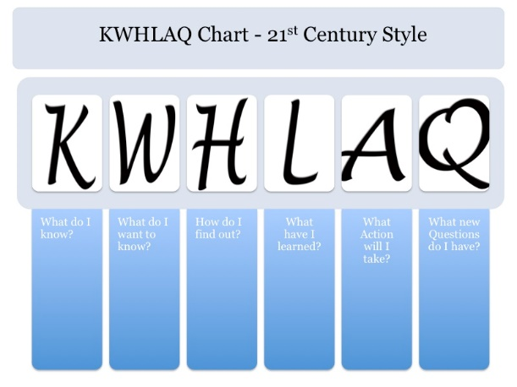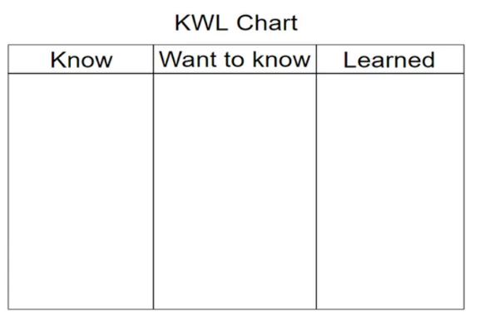

Prior to this lesson, watch the following videos:
https://www.youtube.com/watch?v=cv5WLLYo-fk
https://www.youtube.com/watch?v=qybUFnY7Y8w
And here is one done by Myth Buster’s:
https://www.youtube.com/watch?v=Z5M6VRsME-Q
The teacher will present a biography of Rube Goldberg to the students.
http://www.cccoe.net/tdf/Hensley/rgic/Handout.pdf

Instructional Activities – Step by step detailed instructions for your chosen strategy
Phase I – Day 1

- Discuss Key Vocabulary and visual and video connections.
- Activating Strategy – KWLHAQ – More accessible version - KWL
- Watch the Rube Goldberg video clips.
- Discuss Rube Goldberg and his work.
- Describe his machines.
- Talk about the ideas of simple and compound machines and mechanical advantages. Use visual vocabulary cards.
- What are some examples of useful machines?
- Briefly discuss the engineering design process. Use visuals from video.
- Discuss the SCAMPER strategy and how we can use it to create Rube Goldberg machines.
- Watch the Rube Goldberg video clips again if time allows.

SCAMPER
When to use it - Use it to discover more ideas when you are running out.
How to use it
SCAMPER - Substitute, Combine, Adapt, Modify, put to other uses, Eliminate, Rearrange – Modify the strategy as needed to include fewer steps and make sure the vocabulary is accessible for all learners. Simplify it to say – Making Changes. Also utilize peer helpers for students who need more support.

Phase II – Day 2
1. Define the six simple machines. Consider using some of the suggested websites to assist the process. Use concrete examples, vocabulary cards and videos.
2. Have each student bring in everyday items, like the ones they have seen in the videos, to use as part of their machines. Encourage students to bring in objects representative of their cultures if they choose to do so.
3. Place students in small groups (use peer helpers as needed). Sort the everyday materials and simple machines. Use the Simple Machines Worksheet so the students can keep track of all the materials.
4. Design a Rube Goldberg machine that involves several energy transfers to achieve a mechanical goal. Goals can include moving an object into a specific place, ringing a bell, hitting a mark, etc.…
Guidelines:
- Meet end goal. (The machine works)
- At least 4 steps (energy transfers) prior to achieving goal (add more steps if time allows)
- Can create mid-way goals (i.e., make a ball into a cup).
- Optional: Bring your own ideas for materials!
- Let the kids’ creativity flow! Try not to step in too much!

Higher Level Questions
- Create a model that uses simple machines and energy transfers to meet a mechanical goal and draw the model. How does energy transfer through your model?
- How does your model demonstrate the relationship between force, motion, and gravity? Explain.
Assessment Strategies
Formative:
- Think, Pair, and Share what they would add to their project now after watching the YouTube videos (opening activity). For homework, have students draw a cartoon (like Rube Goldberg would) of their machine and/or project.
- Use the Twitter board or the Important Thing Poster to get sticky note feedback from the students regarding their metacognition and reflection of their progress as they move through the project task.

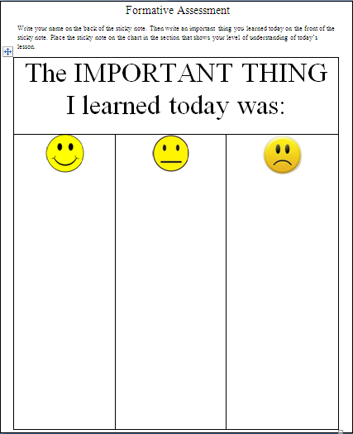
Summative –
- Produce a completed Rube Goldberg machine with small group and complete an individual design process worksheet.
- Use the AIMS Physical Science Assessment to assess AKS proficiency for simple machines.

Use the rubric below to assess the Rube Goldberg STEAM Build Projects.
Project Rubric
CATEGORY | 4 | 3 | 2 | 1
Content - Accuracy X2 | All social studies concepts in the project are accurate and align with the AKS standards. | 99-80% of the social studies concepts in the project are accurate and align with the AKS standards. | 79-70% of the social studies concepts in the project are accurate and align with the AKS standards. | Less than 70% of the social studies concepts in the project are accurate and align with the AKS standards.
Knowledge Gained X2 | Student can accurately answer all questions related to the learning target in the project and the technical processes used to create the project. | Student can accurately answer most questions related to the learning target and to technical processes used to create the project. | Student can accurately answer some questions related to the learning target and to technical processes used to create the project. | Student appears to have little knowledge related to the learning target or technical processes used in the project.
Written Expression | Every part of the project shows precise written expression free of grammar, spelling, and usage errors. | Every part of the project shows precise written expression mostly free of grammar, spelling, and usage errors. | Every part of the project shows precise written expression somewhat free of grammar, spelling, and usage errors. | Every part of the project shows many errors in written expression including many errors in grammar, spelling, and usage.
Attractiveness & Organization | The work has exceptionally attractive formatting and well-organized information. | The work has attractive formatting and well-organized information. | The work has well-organized information. | The work's formatting and organization of material are confusing to the reader.
Scoring Guidelines
Points Earned | Grade Equivalent
24 | 100
23 | 97
22 | 93
21 | 90
20 | 97
19 | 83
18 | 80
17 | 79
16 | 77
15 | 75
14 | 74
13 | 72
12 | 70
11 and below | 69

Simple Machines STEAM Build Recording Sheet
Name __________________________________ Date _______________
Group Members ______________________________________________________________
How do simple machines make work easier?

Choose 2 simple machines to compare and contrast.
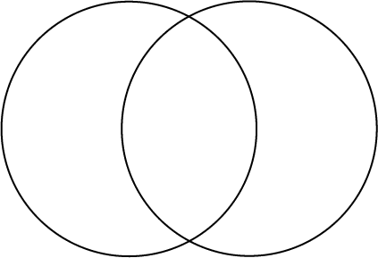
Describe the simple machines your group used to make your Rube Goldberg machines.

Describe the energy transfers performed by your machine.
Sketch your design.

Homework Extension: Write a short story, draw a picture, or bring in a group of objects in which an object is in motion and the motion stops them starts again. The object can be anything you find at home to use. Examples include a bicycle, roller skate, bat, paddle, ball, or other object. In your story describe the force that causes a change in motion.

